Stub, Totally Stub and NSSA Networks

Alen Ovalles

**Purpose**

The purpose of this lab was to get familiar with stubby, totally stubby, and Not-so-stubby-area (NSSA), with a little reminder about EIGRP mixed in. Understanding the difference between the LSA packets that are able to travel throughout each network and how each routing table allows some routes over other network areas.

**Background**

**Area Border Router (ABR)** is an OSPF router that has one or more interfaces in the backbone area and one or more interfaces in a non-backbone area. **Autonomous System Border Router (ASBR)**, connects to an area, and also to an external AS.

**Stubby Area**, is when the ABR does not propagate external routes into the stub area but instead replaces them with a default path. Along with LSA overhead, this reduces the OSPF topology. Stub areas allow the advertising of external routes into an area to be regulated. You suppress external route advertisements via the ABR by defining an area border router (ABR) interface to the area as a stub interface. In exchange, this decreases the CPU / memory used by the nodes to manage the database of topologies. With stub areas, the ABR does not give the Type 5 LSA. Instead, a default route that it sends out to the stub area nodes is included in the Type 3 LSA.

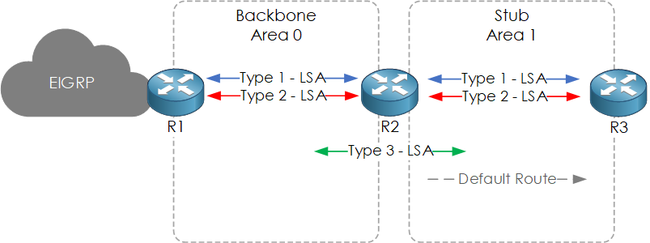

**Totally Stubby Area** is similar to stub areas, in the fact that they do not receive type 4 or 5 LSAs from their ABRs. However, with Totally stubby areas the Type 3 (inter-area advertisement) is also removed, and a single default route is injected by the ABR.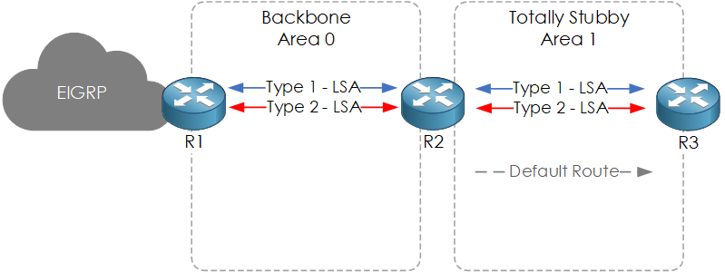

**Not-So-Stubby-Area** is similar to a stub area, but with the addition of an ASBR, is often referred to as NSSA. Thus, the ABR can still send Type 3 (inter-area) LSAs. However, the ASBR sends an LSA Type 7 announcing its external routes to the ABR because the principle of stub areas is that the LSA Type 5 is not sent. The ABR then transforms this LSA Type 7 into a Type 5. NASA's can act either as a stub (shown below) or as a fully stubby area. Type 3 LSAs are also deleted with Not-so-stubby area.

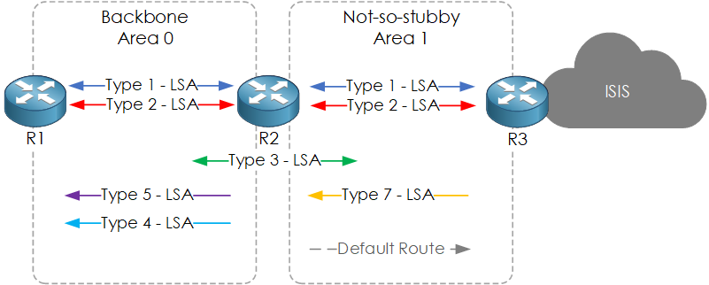

**LSA Type 1**

**Router LSA** is commonly referred to as the LSA router. This type of LSA defines all the prefixes and devices directly attached to a router. This also involves things such as virtual-links. The last thing to remember about this type is that it always remains within the area to which the router belongs.

**LSA Type 2**

**Network LSA** is to calculate the best paths that help to simplify in a router. Network LSA is Type 2. In an OSPF network, this is advertised by the DR and describes all the neighbors in the area. This involves the common prefix for IP that they often operate on. These advertisements also remain within the area, like the type 1 LSA. Type 1 and Type 2 LSA's are flooded between routers sharing a common area.

**LSA Type 3**

**Summary LSA** is sent by the ABR to advertise inter-area routes and is shared into an area to describe neighbors’ OUTSIDE of that area. This will cover your inter-area routes. This is noted by the “O IA” next to these routes in the routing table. One last thing to note here is while they are called Summary LSAs, there is no actual summarization taking place.

**LSA Type 4**

**Summary ASBR LSA** is sent by the ABR advertising the path back to the ASBR. Type4 LSAs are similar to type 3 LSAs but instead of being generated by the ABR, they are generated by the ASBR (autonomous system border router). The key difference from a type 3 LSA though is that the link-state id is the router-id of the ASBR in the case of the type 4 LSA.

**LSA Type 5**

**Autonomous system external LSA** is sent by the ASBR to advertise external routes. Routes that are redistributed into the area are listed in Type 5. These are called external routes and are assigned "O E1" or "O E2" in the routing table. The distinction here is how the expense of a path is measured. Only the cost which is identified during redistribution is used for O E2 routes, which are the default form. O E1 is different because it utilizes the expense of the total route. In addition to the cost to get to the actual ASBR, this includes the cost stated during redistribution.

**LSA Type 7**

**Not-so-stubby area LSA** is only found within a not-so-stubby area. They are generated by the ASBR within the NSSA to describe external routes that are redistributed into the area. The type 7 LSA stays within the NSSA as well. When it leaves the NSSA, it is translated to a type 5 LSA by the ABR. These routes show up in the routing table with the N1 and N2 designation. Much like type 5, the cost is determined the same between the 1 and 2 designations as a type 5 LSA.

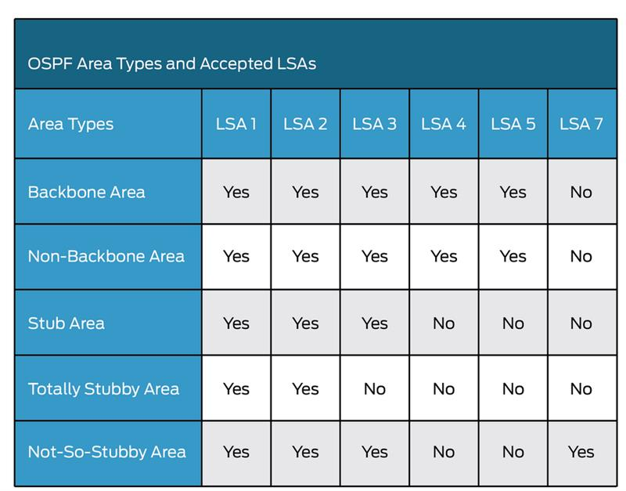

**Lab Summary**

In Packet Tracer, I set up 5 different networks, the Backbone area (area 0), stubby area (area 1), totally stubby area (area 2), not-so-stubby-area (area 3), and EIGRP. 9 routers all connected to successfully ping each other no matter what network or area they are in. The main routers have ip addresses of ?.?.?.1/24 and the area border routers (ABR) have the ip addresses of ?.?.?.2/24. R1 is the backbone area with R2, R3, and R3 the area border routers connected to the stubby area (area 1), the totally stubby area (area 2), and NSSA (area 3). In area 3, R8 is the area border router between NSSA and EIGRP.

**Lab Commands**

* router ospf 1 - Enables ospfv2 on the selected router
* router eigrp 1 - Enables eigrp on the selected router
* area # stub - Converts the selected router to a stubby network
* area # stub no-summary - Converts the selected router to a totally stubby network
* area # nssa - Coverts the selected router to a not-so-stubby-area network
* redistribute ospf 1 metric 1000 33 255 1 1500 - Set the metric per each redistribute command
* redistribute eigrp 1 subnets - Redistribute eigrp to ospf
* show run - Show the whole configuration of the selected device
* show ip route - Shows routing table of selected router
* show ip ospf neighbor - Shows the neighbor routers connected ospf
* clear ip ospf process - restarts the process and all ospf neighbors are restarted

**Network Diagram with IPs**

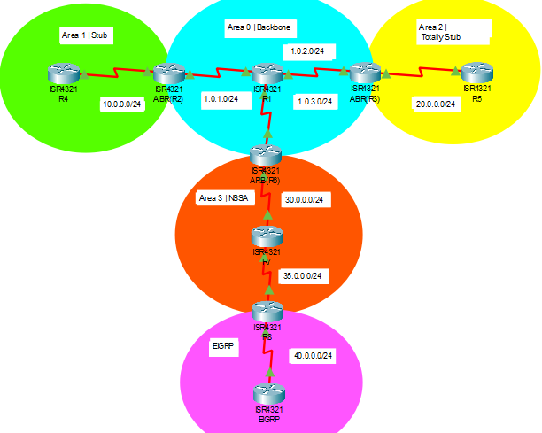

**Configurations**

**BACKBONE AREA**

Router#show run

Building configuration...

Current configuration : 989 bytes

!

hostname BB

!

interface Serial0/1/0

ip address 1.0.1.1 255.255.255.0

!

interface Serial0/1/1

ip address 1.0.2.1 255.255.255.0

clock rate 2000000

!

interface Serial0/2/0

ip address 1.0.3.1 255.255.255.0

!

router ospf 1

router-id 1.1.1.1

log-adjacency-changes

network 1.0.1.0 0.0.0.255 area 0

network 1.0.2.0 0.0.0.255 area 0

network 1.0.3.0 0.0.0.255 area 0

!

end

BB#show ip route

Codes: L - local, C - connected, S - static, R - RIP, M - mobile, B - BGP

D - EIGRP, EX - EIGRP external, O - OSPF, IA - OSPF inter area

N1 - OSPF NSSA external type 1, N2 - OSPF NSSA external type 2

E1 - OSPF external type 1, E2 - OSPF external type 2, E - EGP

i - IS-IS, L1 - IS-IS level-1, L2 - IS-IS level-2, ia - IS-IS inter area

* - candidate default, U - per-user static route, o - ODR

P - periodic downloaded static route

Gateway of last resort is not set

1.0.0.0/8 is variably subnetted, 6 subnets, 2 masks

C 1.0.1.0/24 is directly connected, Serial0/1/0

L 1.0.1.1/32 is directly connected, Serial0/1/0

C 1.0.2.0/24 is directly connected, Serial0/1/1

L 1.0.2.1/32 is directly connected, Serial0/1/1

C 1.0.3.0/24 is directly connected, Serial0/2/0

L 1.0.3.1/32 is directly connected, Serial0/2/0

10.0.0.0/24 is subnetted, 1 subnets

O IA 10.0.0.0/24 [110/128] via 1.0.1.2, 00:01:52, Serial0/1/0

20.0.0.0/24 is subnetted, 1 subnets

O IA 20.0.0.0/24 [110/128] via 1.0.2.2, 00:01:52, Serial0/1/1

30.0.0.0/24 is subnetted, 1 subnets

O IA 30.0.0.0/24 [110/128] via 1.0.3.2, 00:01:42, Serial0/2/0

35.0.0.0/24 is subnetted, 1 subnets

O IA 35.0.0.0/24 [110/192] via 1.0.3.2, 00:01:42, Serial0/2/0

40.0.0.0/24 is subnetted, 1 subnets

O E2 40.0.0.0/24 [110/20] via 1.0.3.2, 00:01:42, Serial0/2/0

BB#show ip ospf neighbor

Neighbor ID Pri State Dead Time Address Interface

3.3.3.3 0 FULL/ - 00:00:34 1.0.2.2 Serial0/1/1

2.2.2.2 0 FULL/ - 00:00:37 1.0.1.2 Serial0/1/0

4.4.4.4 0 FULL/ - 00:00:37 1.0.3.2 Serial0/2/0

BB#ping 10.0.0.1

Sending 5, 100-byte ICMP Echos to 10.0.0.1, timeout is 2 seconds:

!!!!!

Success rate is 100 percent (5/5), round-trip min/avg/max = 2/8/16 ms

BB#ping 20.0.0.1

Sending 5, 100-byte ICMP Echos to 20.0.0.1, timeout is 2 seconds:

!!!!!

Success rate is 100 percent (5/5), round-trip min/avg/max = 4/7/13 ms

BB#ping 30.0.0.1

Sending 5, 100-byte ICMP Echos to 30.0.0.1, timeout is 2 seconds:

!!!!!

Success rate is 100 percent (5/5), round-trip min/avg/max = 2/7/15 ms

BB#ping 40.0.0.1

Sending 5, 100-byte ICMP Echos to 40.0.0.1, timeout is 2 seconds:

!!!!!

Success rate is 100 percent (5/5), round-trip min/avg/max = 8/18/30 ms

**ABR(R2)**

Router#show run

Building configuration...

Current configuration : 863 bytes

!

hostname Router

!

interface Serial0/1/0

ip address 1.0.1.2 255.255.255.0

clock rate 2000000

!

interface Serial0/1/1

ip address 10.0.0.2 255.255.255.0

clock rate 2000000

!

router ospf 1

router-id 2.2.2.2

log-adjacency-changes

area 1 stub

network 10.0.0.0 0.0.0.255 area 1

network 1.0.1.0 0.0.0.255 area 0

!

end

Router#show ip route

Codes: L - local, C - connected, S - static, R - RIP, M - mobile, B - BGP

D - EIGRP, EX - EIGRP external, O - OSPF, IA - OSPF inter area

N1 - OSPF NSSA external type 1, N2 - OSPF NSSA external type 2

E1 - OSPF external type 1, E2 - OSPF external type 2, E - EGP

i - IS-IS, L1 - IS-IS level-1, L2 - IS-IS level-2, ia - IS-IS inter area

* - candidate default, U - per-user static route, o - ODR

P - periodic downloaded static route

Gateway of last resort is not set

1.0.0.0/8 is variably subnetted, 4 subnets, 2 masks

C 1.0.1.0/24 is directly connected, Serial0/1/0

L 1.0.1.2/32 is directly connected, Serial0/1/0

O 1.0.2.0/24 [110/128] via 1.0.1.1, 00:04:00, Serial0/1/0

O 1.0.3.0/24 [110/128] via 1.0.1.1, 00:04:00, Serial0/1/0

10.0.0.0/8 is variably subnetted, 2 subnets, 2 masks

C 10.0.0.0/24 is directly connected, Serial0/1/1

L 10.0.0.2/32 is directly connected, Serial0/1/1

20.0.0.0/24 is subnetted, 1 subnets

O IA 20.0.0.0/24 [110/192] via 1.0.1.1, 00:04:00, Serial0/1/0

30.0.0.0/24 is subnetted, 1 subnets

O IA 30.0.0.0/24 [110/192] via 1.0.1.1, 00:03:50, Serial0/1/0

35.0.0.0/24 is subnetted, 1 subnets

O IA 35.0.0.0/24 [110/256] via 1.0.1.1, 00:03:50, Serial0/1/0

40.0.0.0/24 is subnetted, 1 subnets

O E2 40.0.0.0/24 [110/20] via 1.0.1.1, 00:03:50, Serial0/1/0

Router#show ip ospf neighbor

Neighbor ID Pri State Dead Time Address Interface

10.10.10.10 0 FULL/ - 00:00:39 10.0.0.1 Serial0/1/1

1.1.1.1 0 FULL/ - 00:00:32 1.0.1.1 Serial0/1/0

**STUBBY AREA**

Router#show run

Building configuration...

Current configuration : 804 bytes

!

hostname Stub

!

interface Serial0/1/1

ip address 10.0.0.1 255.255.255.0

!

router ospf 1

router-id 10.10.10.10

log-adjacency-changes

area 1 stub

network 10.0.0.0 0.0.0.255 area 1

!

end

Stubby#show ip route

Codes: L - local, C - connected, S - static, R - RIP, M - mobile, B - BGP

D - EIGRP, EX - EIGRP external, O - OSPF, IA - OSPF inter area

N1 - OSPF NSSA external type 1, N2 - OSPF NSSA external type 2

E1 - OSPF external type 1, E2 - OSPF external type 2, E - EGP

i - IS-IS, L1 - IS-IS level-1, L2 - IS-IS level-2, ia - IS-IS inter area

* - candidate default, U - per-user static route, o - ODR

P - periodic downloaded static route

Gateway of last resort is 10.0.0.2 to network 0.0.0.0

1.0.0.0/24 is subnetted, 3 subnets

O IA 1.0.1.0/24 [110/128] via 10.0.0.2, 00:02:40, Serial0/1/1

O IA 1.0.2.0/24 [110/192] via 10.0.0.2, 00:02:25, Serial0/1/1

O IA 1.0.3.0/24 [110/192] via 10.0.0.2, 00:02:25, Serial0/1/1

10.0.0.0/8 is variably subnetted, 2 subnets, 2 masks

C 10.0.0.0/24 is directly connected, Serial0/1/1

L 10.0.0.1/32 is directly connected, Serial0/1/1

20.0.0.0/24 is subnetted, 1 subnets

O IA 20.0.0.0/24 [110/256] via 10.0.0.2, 00:02:25, Serial0/1/1

30.0.0.0/24 is subnetted, 1 subnets

O IA 30.0.0.0/24 [110/256] via 10.0.0.2, 00:02:15, Serial0/1/1

35.0.0.0/24 is subnetted, 1 subnets

O IA 35.0.0.0/24 [110/320] via 10.0.0.2, 00:02:15, Serial0/1/1

O*IA 0.0.0.0/0 [110/65] via 10.0.0.2, 00:02:40, Serial0/1/1

Stubby#show ip ospf neighbor

Neighbor ID Pri State Dead Time Address Interface

2.2.2.2 0 FULL/ - 00:00:33 10.0.0.2 Serial0/1/1

Stub#ping 1.0.1.1

Sending 5, 100-byte ICMP Echos to 1.0.1.1, timeout is 2 seconds:

!!!!!

Success rate is 100 percent (5/5), round-trip min/avg/max = 2/8/18 ms

Stub#ping 1.0.2.1

Sending 5, 100-byte ICMP Echos to 1.0.2.1, timeout is 2 seconds:

!!!!!

Success rate is 100 percent (5/5), round-trip min/avg/max = 2/11/17 ms

Stub#ping 1.0.3.1

Sending 5, 100-byte ICMP Echos to 1.0.3.1, timeout is 2 seconds:

!!!!!

Success rate is 100 percent (5/5), round-trip min/avg/max = 2/7/16 ms

Stub#ping 20.0.0.1

Sending 5, 100-byte ICMP Echos to 20.0.0.1, timeout is 2 seconds:

!!!!!

Success rate is 100 percent (5/5), round-trip min/avg/max = 4/14/25 ms

Stub#ping 30.0.0.1

Sending 5, 100-byte ICMP Echos to 30.0.0.1, timeout is 2 seconds:

!!!!!

Success rate is 100 percent (5/5), round-trip min/avg/max = 9/21/36 ms

Stub#ping 40.0.0.1

Sending 5, 100-byte ICMP Echos to 40.0.0.1, timeout is 2 seconds:

!!!!!

Success rate is 100 percent (5/5), round-trip min/avg/max = 6/12/22 ms

**ABR(R3)**

Router#show run

Building configuration...

Current configuration : 888 bytes

!

hostname Router

!

interface Serial0/1/0

ip address 20.0.0.2 255.255.255.0

clock rate 2000000

!

interface Serial0/1/1

ip address 1.0.2.2 255.255.255.0

!

router ospf 1

router-id 3.3.3.3

log-adjacency-changes

area 2 stub no-summary

network 20.0.0.0 0.0.0.255 area 2

network 1.0.3.0 0.0.0.255 area 0

network 1.0.2.0 0.0.0.255 area 0

!

end

Router#show ip route

Codes: L - local, C - connected, S - static, R - RIP, M - mobile, B - BGP

D - EIGRP, EX - EIGRP external, O - OSPF, IA - OSPF inter area

N1 - OSPF NSSA external type 1, N2 - OSPF NSSA external type 2

E1 - OSPF external type 1, E2 - OSPF external type 2, E - EGP

i - IS-IS, L1 - IS-IS level-1, L2 - IS-IS level-2, ia - IS-IS inter area

* - candidate default, U - per-user static route, o - ODR

P - periodic downloaded static route

Gateway of last resort is not set

1.0.0.0/8 is variably subnetted, 4 subnets, 2 masks

O 1.0.1.0/24 [110/128] via 1.0.2.1, 00:04:27, Serial0/1/1

C 1.0.2.0/24 is directly connected, Serial0/1/1

L 1.0.2.2/32 is directly connected, Serial0/1/1

O 1.0.3.0/24 [110/128] via 1.0.2.1, 00:04:27, Serial0/1/1

10.0.0.0/24 is subnetted, 1 subnets

O IA 10.0.0.0/24 [110/192] via 1.0.2.1, 00:04:27, Serial0/1/1

20.0.0.0/8 is variably subnetted, 2 subnets, 2 masks

C 20.0.0.0/24 is directly connected, Serial0/1/0

L 20.0.0.2/32 is directly connected, Serial0/1/0

30.0.0.0/24 is subnetted, 1 subnets

O IA 30.0.0.0/24 [110/192] via 1.0.2.1, 00:04:17, Serial0/1/1

35.0.0.0/24 is subnetted, 1 subnets

O IA 35.0.0.0/24 [110/256] via 1.0.2.1, 00:04:17, Serial0/1/1

40.0.0.0/24 is subnetted, 1 subnets

O E2 40.0.0.0/24 [110/20] via 1.0.2.1, 00:04:17, Serial0/1/1

Router#show ip ospf neighbor

Neighbor ID Pri State Dead Time Address Interface

20.20.20.20 0 FULL/ - 00:00:30 20.0.0.1 Serial0/1/0

1.1.1.1 0 FULL/ - 00:00:33 1.0.2.1 Serial0/1/1

**TOTALLY STUBBY AREA**

Router#show run

Building configuration...

Current configuration : 815 bytes

!

hostname Totally_Stub

!

interface Serial0/1/0

ip address 20.0.0.1 255.255.255.0

!

router ospf 1

router-id 20.20.20.20

log-adjacency-changes

area 2 stub no-summary

network 20.0.0.0 0.0.0.255 area 2

!

end

Totally_Stub#show ip route

Codes: L - local, C - connected, S - static, R - RIP, M - mobile, B - BGP

D - EIGRP, EX - EIGRP external, O - OSPF, IA - OSPF inter area

N1 - OSPF NSSA external type 1, N2 - OSPF NSSA external type 2

E1 - OSPF external type 1, E2 - OSPF external type 2, E - EGP

i - IS-IS, L1 - IS-IS level-1, L2 - IS-IS level-2, ia - IS-IS inter area

* - candidate default, U - per-user static route, o - ODR

P - periodic downloaded static route

Gateway of last resort is 20.0.0.2 to network 0.0.0.0

20.0.0.0/8 is variably subnetted, 2 subnets, 2 masks

C 20.0.0.0/24 is directly connected, Serial0/1/0

L 20.0.0.1/32 is directly connected, Serial0/1/0

O*IA 0.0.0.0/0 [110/65] via 20.0.0.2, 00:03:12, Serial0/1/0

Totally_Stub#show ip ospf neighbor

Neighbor ID Pri State Dead Time Address Interface

3.3.3.3 0 FULL/ - 00:00:30 20.0.0.2 Serial0/1/0

Totally_Stub#show ip ospf neighbor

Totally_Stub#ping 1.0.1.1

Sending 5, 100-byte ICMP Echos to 1.0.1.1, timeout is 2 seconds:

!!!!!

Success rate is 100 percent (5/5), round-trip min/avg/max = 2/10/17 ms

Totally_Stub#ping 1.0.2.1

Sending 5, 100-byte ICMP Echos to 1.0.2.1, timeout is 2 seconds:

!!!!!

Success rate is 100 percent (5/5), round-trip min/avg/max = 3/9/26 ms

Totally_Stub#ping 1.0.3.1

Sending 5, 100-byte ICMP Echos to 1.0.3.1, timeout is 2 seconds:

!!!!!

Success rate is 100 percent (5/5), round-trip min/avg/max = 7/11/18 ms

Totally_Stub#ping 10.0.0.1

Sending 5, 100-byte ICMP Echos to 10.0.0.1, timeout is 2 seconds:

!!!!!

Success rate is 100 percent (5/5), round-trip min/avg/max = 4/11/20 ms

Totally_Stub#ping 30.0.0.1

Sending 5, 100-byte ICMP Echos to 30.0.0.1, timeout is 2 seconds:

!!!!!

Success rate is 100 percent (5/5), round-trip min/avg/max = 9/19/27 ms

Totally_Stub#ping 40.0.0.1

Sending 5, 100-byte ICMP Echos to 40.0.0.1, timeout is 2 seconds:

!!!!!

Success rate is 100 percent (5/5), round-trip min/avg/max = 10/17/42 ms

**ABR(R6)**

Router#show run

Building configuration...

Current configuration : 843 bytes

!

hostname Router

!

interface Serial0/1/0

ip address 1.0.3.2 255.255.255.0

clock rate 2000000

!

interface Serial0/1/1

ip address 30.0.0.2 255.255.255.0

!

router ospf 1

router-id 4.4.4.4

log-adjacency-changes

area 3 nssa

network 30.0.0.0 0.0.0.255 area 3

network 1.0.3.0 0.0.0.255 area 0

!

end

Router#show ip route

Codes: L - local, C - connected, S - static, R - RIP, M - mobile, B - BGP

D - EIGRP, EX - EIGRP external, O - OSPF, IA - OSPF inter area

N1 - OSPF NSSA external type 1, N2 - OSPF NSSA external type 2

E1 - OSPF external type 1, E2 - OSPF external type 2, E - EGP

i - IS-IS, L1 - IS-IS level-1, L2 - IS-IS level-2, ia - IS-IS inter area

* - candidate default, U - per-user static route, o - ODR

P - periodic downloaded static route

Gateway of last resort is not set

1.0.0.0/8 is variably subnetted, 4 subnets, 2 masks

O 1.0.1.0/24 [110/128] via 1.0.3.1, 00:04:50, Serial0/1/0

O 1.0.2.0/24 [110/128] via 1.0.3.1, 00:04:50, Serial0/1/0

C 1.0.3.0/24 is directly connected, Serial0/1/0

L 1.0.3.2/32 is directly connected, Serial0/1/0

10.0.0.0/24 is subnetted, 1 subnets

O IA 10.0.0.0/24 [110/192] via 1.0.3.1, 00:04:50, Serial0/1/0

20.0.0.0/24 is subnetted, 1 subnets

O IA 20.0.0.0/24 [110/192] via 1.0.3.1, 00:04:50, Serial0/1/0

30.0.0.0/8 is variably subnetted, 2 subnets, 2 masks

C 30.0.0.0/24 is directly connected, Serial0/1/1

L 30.0.0.2/32 is directly connected, Serial0/1/1

35.0.0.0/24 is subnetted, 1 subnets

O 35.0.0.0/24 [110/128] via 30.0.0.1, 00:04:45, Serial0/1/1

40.0.0.0/24 is subnetted, 1 subnets

O N2 40.0.0.0/24 [110/20] via 30.0.0.1, 00:04:45, Serial0/1/1

Router#show ip ospf neighbor

Neighbor ID Pri State Dead Time Address Interface

30.30.30.30 0 FULL/ - 00:00:39 30.0.0.1 Serial0/1/1

1.1.1.1 0 FULL/ - 00:00:36 1.0.3.1 Serial0/1/0

**NSSA AREA**

Router#show run

Building configuration...

Current configuration : 849 bytes

!

hostname NSSA

!

interface Serial0/1/0

ip address 35.0.0.1 255.255.255.0

!

interface Serial0/1/1

ip address 30.0.0.1 255.255.255.0

clock rate 2000000

!

router ospf 1

router-id 30.30.30.30

log-adjacency-changes

area 3 nssa

network 30.0.0.0 0.0.0.255 area 3

network 35.0.0.0 0.0.0.255 area 3

!

end

NSSA#show ip route

Codes: L - local, C - connected, S - static, R - RIP, M - mobile, B - BGP

D - EIGRP, EX - EIGRP external, O - OSPF, IA - OSPF inter area

N1 - OSPF NSSA external type 1, N2 - OSPF NSSA external type 2

E1 - OSPF external type 1, E2 - OSPF external type 2, E - EGP

i - IS-IS, L1 - IS-IS level-1, L2 - IS-IS level-2, ia - IS-IS inter area

* - candidate default, U - per-user static route, o - ODR

P - periodic downloaded static route

Gateway of last resort is not set

1.0.0.0/24 is subnetted, 3 subnets

O IA 1.0.1.0/24 [110/192] via 30.0.0.2, 00:03:15, Serial0/1/1

O IA 1.0.2.0/24 [110/192] via 30.0.0.2, 00:03:15, Serial0/1/1

O IA 1.0.3.0/24 [110/128] via 30.0.0.2, 00:03:15, Serial0/1/1

10.0.0.0/24 is subnetted, 1 subnets

O IA 10.0.0.0/24 [110/256] via 30.0.0.2, 00:03:15, Serial0/1/1

20.0.0.0/24 is subnetted, 1 subnets

O IA 20.0.0.0/24 [110/256] via 30.0.0.2, 00:03:15, Serial0/1/1

30.0.0.0/8 is variably subnetted, 2 subnets, 2 masks

C 30.0.0.0/24 is directly connected, Serial0/1/1

L 30.0.0.1/32 is directly connected, Serial0/1/1

35.0.0.0/8 is variably subnetted, 2 subnets, 2 masks

C 35.0.0.0/24 is directly connected, Serial0/1/0

L 35.0.0.1/32 is directly connected, Serial0/1/0

40.0.0.0/24 is subnetted, 1 subnets

O N2 40.0.0.0/24 [110/20] via 35.0.0.2, 00:03:25, Serial0/1/0

NSSA#show ip ospf neighbor

Neighbor ID Pri State Dead Time Address Interface

4.4.4.4 0 FULL/ - 00:00:39 30.0.0.2 Serial0/1/1

35.35.35.35 0 FULL/ - 00:00:39 35.0.0.2 Serial0/1/0

NSSA#ping 1.0.1.1

Sending 5, 100-byte ICMP Echos to 1.0.1.1, timeout is 2 seconds:

!!!!!

Success rate is 100 percent (5/5), round-trip min/avg/max = 6/11/20 ms

NSSA#ping 1.0.2.1

Sending 5, 100-byte ICMP Echos to 1.0.2.1, timeout is 2 seconds:

!!!!!

Success rate is 100 percent (5/5), round-trip min/avg/max = 2/9/16 ms

NSSA#ping 1.0.3.1

Sending 5, 100-byte ICMP Echos to 1.0.3.1, timeout is 2 seconds:

!!!!!

Success rate is 100 percent (5/5), round-trip min/avg/max = 2/8/16 ms

NSSA#ping 10.0.0.1

Sending 5, 100-byte ICMP Echos to 10.0.0.1, timeout is 2 seconds:

!!!!!

Success rate is 100 percent (5/5), round-trip min/avg/max = 4/11/32 ms

NSSA#ping 20.0.0.1

Sending 5, 100-byte ICMP Echos to 20.0.0.1, timeout is 2 seconds:

!!!!!

Success rate is 100 percent (5/5), round-trip min/avg/max = 4/7/12 ms

NSSA#ping 40.0.0.1

Sending 5, 100-byte ICMP Echos to 40.0.0.1, timeout is 2 seconds:

!!!!!

Success rate is 100 percent (5/5), round-trip min/avg/max = 6/8/15 ms

**ABR(R8)**

Router#show run

Building configuration...

Current configuration : 940 bytes

!

hostname Router

!

interface Serial0/1/0

ip address 35.0.0.2 255.255.255.0

clock rate 2000000

!

interface Serial0/1/1

ip address 40.0.0.2 255.255.255.0

!

router eigrp 1

redistribute ospf 1 metric 1000 33 255 1 1500

network 40.0.0.0 0.0.0.255

!

router ospf 1

router-id 35.35.35.35

log-adjacency-changes

area 3 nssa

redistribute eigrp 1 subnets

network 35.0.0.0 0.0.0.255 area 3

!

end

Router#show ip route

Codes: L - local, C - connected, S - static, R - RIP, M - mobile, B - BGP

D - EIGRP, EX - EIGRP external, O - OSPF, IA - OSPF inter area

N1 - OSPF NSSA external type 1, N2 - OSPF NSSA external type 2

E1 - OSPF external type 1, E2 - OSPF external type 2, E - EGP

i - IS-IS, L1 - IS-IS level-1, L2 - IS-IS level-2, ia - IS-IS inter area

* - candidate default, U - per-user static route, o - ODR

P - periodic downloaded static route

Gateway of last resort is not set

1.0.0.0/24 is subnetted, 3 subnets

O IA 1.0.1.0/24 [110/256] via 35.0.0.1, 00:04:57, Serial0/1/0

O IA 1.0.2.0/24 [110/256] via 35.0.0.1, 00:04:57, Serial0/1/0

O IA 1.0.3.0/24 [110/192] via 35.0.0.1, 00:04:57, Serial0/1/0

10.0.0.0/24 is subnetted, 1 subnets

O IA 10.0.0.0/24 [110/320] via 35.0.0.1, 00:04:57, Serial0/1/0

20.0.0.0/24 is subnetted, 1 subnets

O IA 20.0.0.0/24 [110/320] via 35.0.0.1, 00:04:57, Serial0/1/0

30.0.0.0/24 is subnetted, 1 subnets

O 30.0.0.0/24 [110/128] via 35.0.0.1, 00:05:07, Serial0/1/0

35.0.0.0/8 is variably subnetted, 2 subnets, 2 masks

C 35.0.0.0/24 is directly connected, Serial0/1/0

L 35.0.0.2/32 is directly connected, Serial0/1/0

40.0.0.0/8 is variably subnetted, 2 subnets, 2 masks

C 40.0.0.0/24 is directly connected, Serial0/1/1

L 40.0.0.2/32 is directly connected, Serial0/1/1

Router#show ip ospf neighbor

Neighbor ID Pri State Dead Time Address Interface

30.30.30.30 0 FULL/ - 00:00:32 35.0.0.1 Serial0/1/0

**EIGRP AREA**

Router#show run

Building configuration...

Current configuration : 761 bytes

!

hostname EIGRP

!

interface Serial0/1/1

ip address 40.0.0.1 255.255.255.0

clock rate 2000000

!

router eigrp 1

network 40.0.0.0 0.0.0.255

!

end

EIGRP#show ip route

Codes: L - local, C - connected, S - static, R - RIP, M - mobile, B - BGP

D - EIGRP, EX - EIGRP external, O - OSPF, IA - OSPF inter area

N1 - OSPF NSSA external type 1, N2 - OSPF NSSA external type 2

E1 - OSPF external type 1, E2 - OSPF external type 2, E - EGP

i - IS-IS, L1 - IS-IS level-1, L2 - IS-IS level-2, ia - IS-IS inter area

* - candidate default, U - per-user static route, o - ODR

P - periodic downloaded static route

Gateway of last resort is not set

1.0.0.0/24 is subnetted, 3 subnets

D EX 1.0.1.0/24 [170/3080448] via 40.0.0.2, 00:03:25, Serial0/1/1

D EX 1.0.2.0/24 [170/3080448] via 40.0.0.2, 00:03:25, Serial0/1/1

D EX 1.0.3.0/24 [170/3080448] via 40.0.0.2, 00:03:25, Serial0/1/1

10.0.0.0/24 is subnetted, 1 subnets

D EX 10.0.0.0/24 [170/3080448] via 40.0.0.2, 00:03:25, Serial0/1/1

20.0.0.0/24 is subnetted, 1 subnets

D EX 20.0.0.0/24 [170/3080448] via 40.0.0.2, 00:03:25, Serial0/1/1

30.0.0.0/24 is subnetted, 1 subnets

D EX 30.0.0.0/24 [170/3080448] via 40.0.0.2, 00:03:35, Serial0/1/1

35.0.0.0/24 is subnetted, 1 subnets

D EX 35.0.0.0/24 [170/3080448] via 40.0.0.2, 00:03:43, Serial0/1/1

40.0.0.0/8 is variably subnetted, 2 subnets, 2 masks

C 40.0.0.0/24 is directly connected, Serial0/1/1

L 40.0.0.1/32 is directly connected, Serial0/1/1

EIGRP#ping 1.0.1.1

Sending 5, 100-byte ICMP Echos to 1.0.1.1, timeout is 2 seconds:

!!!!!

Success rate is 100 percent (5/5), round-trip min/avg/max = 11/19/26 ms

EIGRP#ping 1.0.2.1

Sending 5, 100-byte ICMP Echos to 1.0.2.1, timeout is 2 seconds:

!!!!!

Success rate is 100 percent (5/5), round-trip min/avg/max = 4/11/32 ms

EIGRP#ping 1.0.3.1

Sending 5, 100-byte ICMP Echos to 1.0.3.1, timeout is 2 seconds:

!!!!!

Success rate is 100 percent (5/5), round-trip min/avg/max = 4/11/18 ms

EIGRP#ping 10.0.0.1

Sending 5, 100-byte ICMP Echos to 10.0.0.1, timeout is 2 seconds:

!!!!!

Success rate is 100 percent (5/5), round-trip min/avg/max = 14/25/43 ms

EIGRP#ping 20.0.0.1

Sending 5, 100-byte ICMP Echos to 20.0.0.1, timeout is 2 seconds:

!!!!!

Success rate is 100 percent (5/5), round-trip min/avg/max = 6/15/23 ms

EIGRP#ping 30.0.0.1

Sending 5, 100-byte ICMP Echos to 30.0.0.1, timeout is 2 seconds:

!!!!!

Success rate is 100 percent (5/5), round-trip min/avg/max = 6/11/15 ms

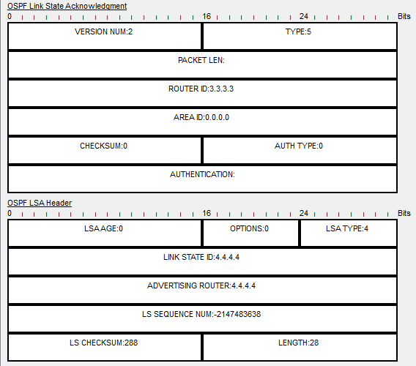

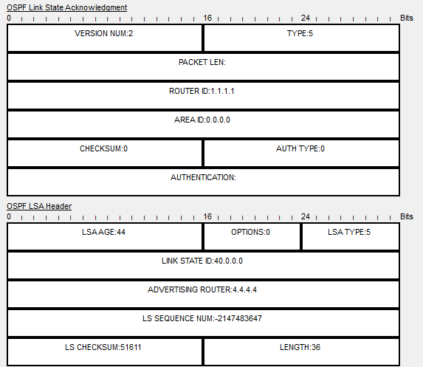

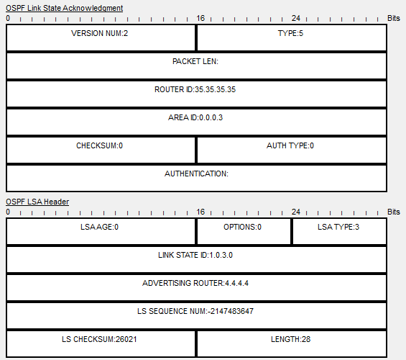

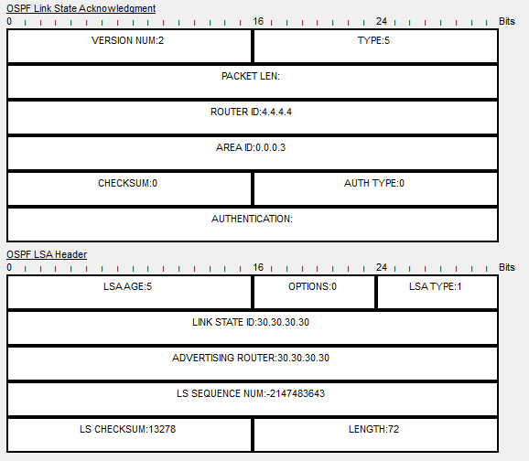

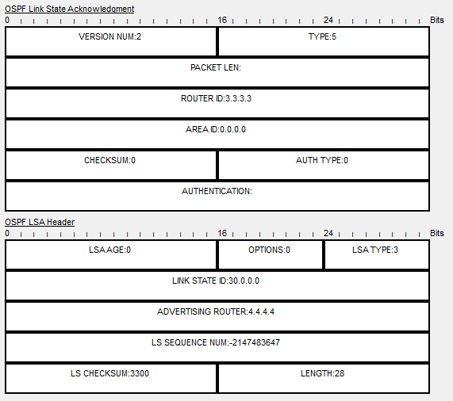

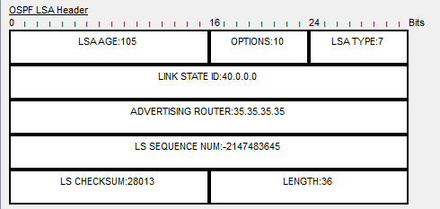

**Problems**

The first problem was how to configure the stubby, totally stubby, and nssa areas. With the help of our team’s meeting, with everyone looking up links and websites about stubby , totally stubby, and nssa during the research phase for the background part of the write-up. Went setting up the configuration the first time, I wasn’t able to ping from the stubby area to the totally stubby area, couldn’t figure it out until the latest team’s meeting with everyone else. Having Nikhil have the same problem as well, allowed me to use the command “clear ip ospf process” to refresh the ospf on each router. WIth eigrp, there were two major problems that came up, the first one was how to configure eigrp on a router. With a little research throughout google and the website Mr. Mason gave us, I was able to figure out the right command to enable eigrp. The next problem was getting E O2 and N O2 routes in the backbone and nssa areas. The problem that I was facing came in with the network statements that I had in each router configuration. I add both 35.0.0.0/24 and 40.0.0.0/24 routes in both router ospf 1 and router eigrp 1. Not knowing the difference until looking at a page in cisco.com listing the difference with the area border route network statements. All I had to do was only have the 35.0.0.0/24 in the router ospf 1 command and 40.0.0.0/24 in router eigrp 1 because it was a area border router. Having 40.0.0.0/24 coming from eigrp and 35.0.0.0/24 coming from ospf. Fixing the eigrp problem also fixed another major problem that I was having in the simulation part of the lab. Before I found out the right eigrp configuration, in simulation mode I was only able to get hello ospf packets (light blue) and none of the LSA type packets (navy blue). After the fixed and a quick save with a restart of the packet tracer, I was able to get different LSA type packets in the simulation mode.

**Conclusion**

In conclusion, this lab was an educated one in that it introduced stubby, totally stubby and nssa as new concepts to Cisco, as well as the different LSA types that each area allows to flow through and negates throughout the process of sending packets to each other. It was also a good reminder about eigrp and continuing to use ospf regularly throughout Cisco. This lab was a little different from the other labs that we have done, it was the first lab that we did a research lab before the process of the packet tracer just for the background for this write up.